**Key Binding in MVVM**

<TextBox AcceptsReturn="False">

<TextBox.InputBindings>

<KeyBinding

Key="Enter"

Command="{Binding SearchCommand}"

CommandParameter="{Binding Path=Text, RelativeSource={RelativeSource AncestorType={x:Type TextBox}}}" />

</TextBox.InputBindings>

</TextBox>

**Toto funguje:**

<Window.InputBindings>

<KeyBinding

Key="G"

Command="{Binding Path=CancelRotationCommand}"/>

</Window.InputBindings>

**Kdyz chci pouzit jen CTRL :**

<Window.InputBindings>

<KeyBinding

Key="LeftCtrl"

Modifiers="Control"

Command="{Binding Path=CancelRotationCommand}"/>

</Window.InputBindings>

Viz take: C:\Users\phlavenka\OneDrive\Nielsen prace\Moje poznamky Nielsen\Commands \CommandParameters.docx

**Pomoci Caliburnu:**

cal:Message.Attach="[Event PreviewKeyDown] = [Action HandleKeyDown($eventArgs)]"

public void HandleKeyDown(KeyEventArgs e)

{

if (Keyboard.Modifiers == ModifierKeys.Control && e.Key == Key.F)

ByIdRepricingControl.InsertIntoQueue();

}

**PageView Vystrihovadlo:**

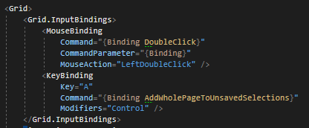

**PageViewModel Vystrihovadlo:**